Senior Performance Choir – CHO30S, CHO40S
Instructor: Mrs. Melanie Urichuk Email: melanie.urichuk@gvsd.ca
http://gvcchoir.weebly.com

Course Description
This auditioned choir meets every day throughout the school year. It is broken up into 2 credits – one for each semester. Classes are largely rehearsal based in preparation for performances throughout the year.

Performance Opportunities
Performances throughout the year include, but are not necessarily limited to:
- Choralfest – Week of November 14th – 18th – Sturgeon Creek United Church, Wpg
- Winter Concert – Wednesday, December 7th, 2016 – 7:30 pm in GVC Gymnasium
- Spring Concert – Thursday, May 25th, 2017 – 7:30 pm in GVC Gymnasium
- Senior Music Tour – Late April – dates TBD. (A small-scale tour in Manitoba)
- Grad Choir – Perform at graduation ceremony (All Grade 12s)

Class Expectations
- Be present, both physically and mentally. This means you will:
  - Have SPECTACULAR attendance at choir. Be present at all rehearsals, workshops, or performances unless you have made arrangements in advance.
  - When you are in choir, you are focused and on task. Choir is a high energy class. Your participation and focus are necessary for us to grow and become our best.
- Bring your music binder & a pencil to every class. Our sheet music is our textbook, and you must return it at the end of each semester. Do NOT use pen, markers, etc. on the music, and do NOT lose your music. You will be charged for replacement music.
- All students are responsible for creating a safe, encouraging learning environment where everyone can thrive. Everyone is important and valued.
- Students are expected to regularly visit the classroom website to listen to repertoire, as well as stay informed for coming events, reminders, and news.

Learning Objectives:
There are 4 Essential Learning Areas in Manitoba’s Grade 9-12 Music Framework. These ELAs are intended to centre around the student as an active and full participant in music-making.
Essential Learning Areas:
- Making Music
- Creating Music
- Connecting with Music
- Responding to Music
Based on these four ELAs, students should be able to use musical tools, to communicate creatively and expressively, connect to context, and reflect on their learning.
Assessment Plan:
In addition to traditional written assignments and tests, students will be assessed on each of the 4 ELAs, as discussed above. Some of this assessment will be observational evidence based on the student’s demonstrated abilities and involvement during class/rehearsal time.

The final cut-off date for each semester will be 1 week prior to the submission of marks.

The mark breakdown is as follows:
- Warm-ups 20%
Written & sung warm-ups will occur at the beginning of each class
- Making Music (Music Language & Skills) 30%
Technical abilities, literacy, theory, Enrichment & Outreach points
- Creating Music (Creative Expression) 10%
Acting through song, conveying appropriate mood
- Connecting with Music (Music and Context) 20%
Music History/Music and Culture assignments
- Responding to Music (Perception, Reflection, & Response) 10%
Personal written responses, program notes, ensemble skills
- Final Choir Singing Test – End of each semester 10%
Will include both sung and written components
All course materials will be labeled with the ELA to which the marks will be allotted. Most assignments will be marked using a rubric scale of 4, like the one below.

1  Beginning  to Develop | 2  Approaching Expectations | 3  Meeting  Expectations | 4  Exceeding Expectations

You will be able to check in at any time on PowerSchool for an update on your mark. I will do my best to keep the GradeBook as up to date as possible.

Concert Attire:
Different types of performances will require different types of performance wear. Formal concerts and tours will generally require head-to-toe black (black shirt, black pants/skirt, black socks/leggings & shoes) while more casual performances may require a uniform of nice jeans and a shirt with no obvious logos on it. We will discuss prior to each performance.

“I want to sing like the birds sing; not worrying about who hears or what they think.”
– Rumi

A Safe Place to Sing
In a safe place, people are kind.
Insults, gossiping, name-calling, and backstabbing do not exist.
Kindness, consideration, and empathy are the normal way of life.
In a safe place, there is laughter.
Not the canned laughter from a TV sitcom, but real laughter that comes from sharing stories, ideas, work, and play.
People sometimes even laugh at themselves.
In a safe place there are rules. Not a lot of rules, but there are some and they are fair. The rules are made by the people who work there and live there.

In a safe place, people listen to one another. They care about each other and they show it.

This place belongs to all of us. Every single one of us belongs here.
This is a safe place to sing!
=

Vocal Hygiene

As part of your choir experience, you are expected to be conscientious of your vocal health.
This means:
- Sleeping well
- Drinking lots of water
- Eating healthy
- Avoiding caffeine (and if you MUST have that coffee - be sure to drink an equal amount of water!)
- NO SMOKING! Smoking is the #1 way to limit your singing. Not only are its effects fast-acting, they inhibit your vocal range & breath support.
Links & Resources:
Sight Singing
https://sightreadingfactory.com/app
http://neilhawes.com/sstheory/sitesing.htm
http://thepracticeroom.net/exercises-main.php

Ear Training and Theory
http://www.good-ear.com/
http://www.teoria.com/index.php
http://www.musictheory.net/
http://www.therhythmtrainer.com/

Apps
MyEar
Theory Cards (Called Interval Cards for Android)
Right Note Lite
Key Signature Quiz
Rhythm Tap - Music Theory Game

Outside-of-School opportunities:
Winkler Festival of the Arts
http://festivalofthearts.wix.com/winklerfota

Central Manitoba Youth Choir
http://centralmca.weebly.com/cmyc
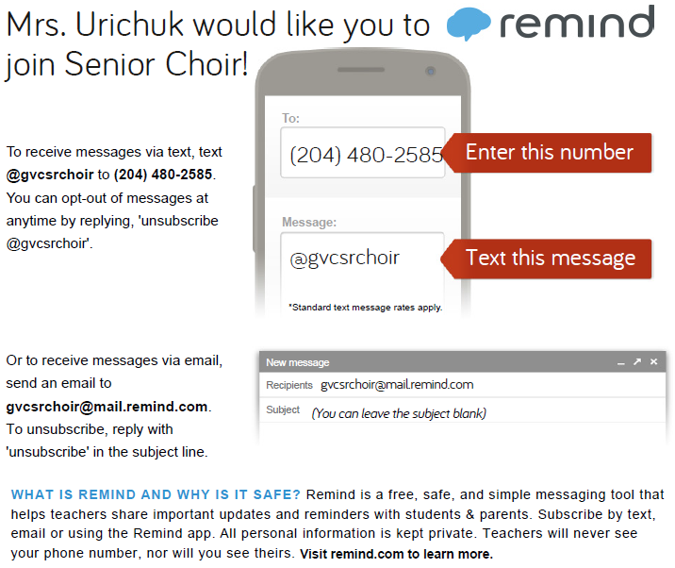

PARENT/GUARDIAN INFORMATION
Please read the information provided on all pages of the Course Outline, then tear off the bottom portion of this page, sign, and return to school this week.

Email: melanie.urichuk@gvsd.ca Phone: 325-8008

At GVC, we use a Student Information program called PowerSchool, which is also accessed through our school website (gvc.gvsd.ca). From here, you can always be kept up to date with your child’s classes.

Please sign below and send this form back to school with your child to acknowledge that you have read and understood the course outline. Thank you!

__________________________________
Student Name

__________________________________
Parent/Guardian Signature

