Reverb (Junior Vocal Jazz) – VJZ10S
Instructor: Mrs. Melanie Urichuk Email: melanie.urichuk@gvsd.ca
http://gvcchoir.weebly.com
Course Description
This is an unauditioned group of singers in grade 9 that meets every day in period 6 of Semester 2. This group focuses on musical skills involved in performing Vocal Jazz contemporary styles, and subscribes to the provincial Vocal Jazz curriculum. This group performs a few times during the semester at a variety of functions. Students in this group are animated, energetic performers, who work hard to learn music quickly and sing independently.

Performance Opportunities
Performances throughout the year include, but are not necessarily limited to:
- Winkler Festival of the Arts – Tuesday, April 19th – time TBA, but likely morning.
- Spring Jazz Night – Thursday, May 19th, 2016 – 7:30 pm in the Zone
- Jazz Café - Date TBA

Class Expectations
- Be present, both physically and mentally. This means you will:
  - Have SPECTACULAR attendance. Be present at all rehearsals, workshops, or performance. Students with poor attendance will be removed from the course.
  - When you are in vocal jazz, you are focused and on task. Your participation and focus are necessary for us to grow and become our best.
- Bring your music binder & a pencil to every class. Our sheet music is our textbook, and you must return it at the end of each semester. Do NOT use pen, markers, etc. on the music, and do NOT lose your music. You will be charged for replacement music.
- All students are responsible for creating a safe, encouraging learning environment where everyone can thrive. Everyone is important and valued.
- Students are expected to regularly visit the classroom website to listen to repertoire and resources, as well as stay informed for coming events, reminders, and news.

Learning Objectives:
There are 4 Essential Learning Areas in Manitoba’s Grade 9-12 Music Framework. These ELAs are intended to centre around the student as an active and full participant in music-making.
Essential Learning Areas:
- Making Music
- Creating Music
- Connecting with Music
- Responding to Music
Based on these four ELAs, students should be able to use musical tools, to communicate creatively and expressively, connect to context, and reflect on their learning.

Assessment Plan:
In addition to traditional written assignments and tests, students will be assessed on each of the 4 ELAs, as discussed above. Some of this assessment will be observational evidence based on the student’s demonstrated abilities and involvement during class/rehearsal time.

The final cut-off date for each semester will be 1 week prior to the submission of marks.

The mark breakdown is as follows:
- Making Music (Music Language & Skills) 30%
Technical abilities, literacy, theory
- Creating Music (Creative Expression) 20%
Acting through song, Circle Singing, improvisation
- Connecting with Music (Music and Context) 20%
Music History/Music and Culture assignments
- Responding to Music (Perception, Reflection, & Response) 20%
Personal written responses, program notes, ensemble skills
- “Small Group” Performances 10%
Preparation and performance (includes written components)
All course materials will be labeled with the ELA to which the marks will be allotted. Most assignments will be marked using a rubric scale of 4, like the one below.

1  Beginning  to Develop | 2  Approaching Expectations | 3  Meeting  Expectations | 4  Exceeding Expectations

You will be able to check in at any time on PowerSchool for an update on your mark. I will do my best to keep the GradeBook as up to date as possible.

Concert Attire:
Different types of performances will require different types of performance wear. Formal concerts and tours will generally require head-to-toe black (black shirt, black pants/skirt, black socks/leggings & shoes) while more casual performances may require a uniform of nice jeans and a shirt with no obvious logos on it. Tenors/Basses generally wear red bowties when we are wearing our formal outfit. We will discuss prior to each performance.

“There are four qualities essential to a great jazz[person]. They are taste, courage, individuality, and irreverence. These are the qualities I want to retain in my music.”
– Stan Getz
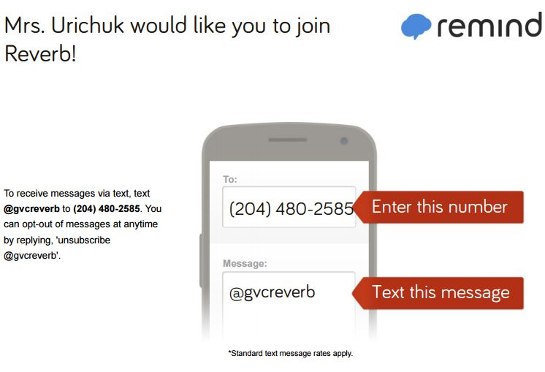
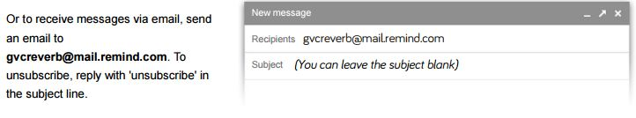

PARENT/GUARDIAN INFORMATION
Please read the information provided on all pages of the Course Outline, then tear off the bottom portion of this page, sign, and return to school this week.

Email: melanie.urichuk@gvsd.ca Phone: 325-8008

At GVC, we use a Student Information program called PowerSchool, which is also accessed through our school website (gvc.gvsd.ca). From here, you can always be kept up to date with your child’s classes.

Please sign below and send this form back to school with your child to acknowledge that you have read and understood the course outline. Thank you!

__________________________________
Student Name

__________________________________
Parent/Guardian Signature

